Steak and Shrimp Dinner
East New Market VFD
Saturday May 19, 2012

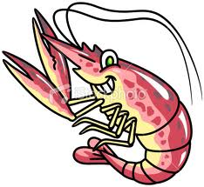
4:00 p.m. - 8:00 p.m.
$20.00 per person
8 oz. Prime Rib
½ Pound Steamed Shrimp
Baked Potato
Green Beans
Salad
Dessert
Tea or Water
Cash Bar
(Chicken Tenders and French Fries Available for Kids)
For tickets please call 410-463-3045
Or visit our website at: http://www.eastnewmarketvfd.com/contactus.cfm

